Azure Storage Queue – Console App
The Azure Storage Queue service provides a mechanism for reliable inter-application messaging to support asynchronous distributed application workflows. This section covers a few fundamental features of the Queue service for adding messages to a queue, processing those messages individually or in a batch, and scaling the service.

Step 1: Create New Console App from Visual Studio Template
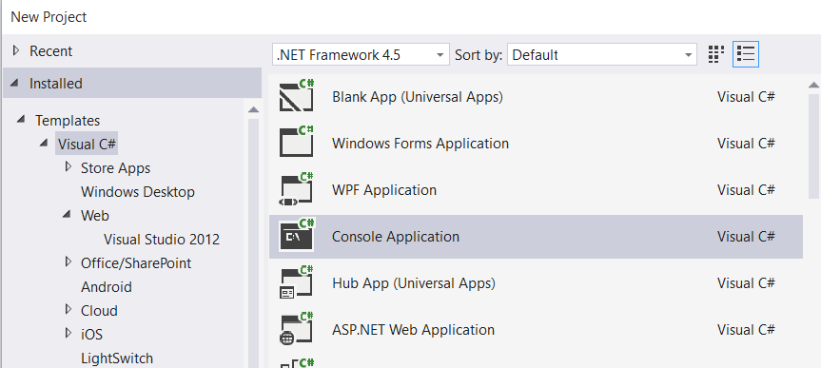

Step 2: Right click on Project name & select “Manage NuGet Packages…”
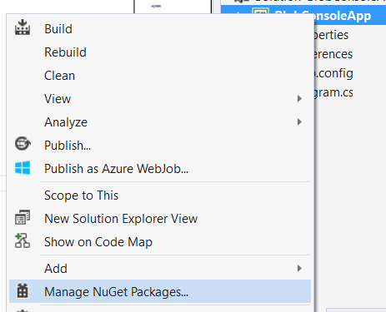

Step 3: Manage NuGet Packages dialog box will open & search for “Azure Storage”
Install “Windows Azure Storage”
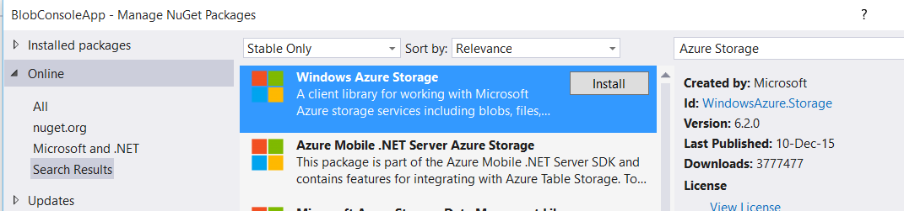

Step 4: Open app.config file, add an entry under the Configuration element, replacing the account name and key with your own storage account details:

<?xml version="1.0" encoding="utf-8" ?>
<configuration>
<startup>
<supportedRuntime version="v4.0" sku=".NETFramework,Version=v4.5" />
</startup>
<appSettings>
<add key="StorageConnectionString" value="DefaultEndpointsProtocol=https;AccountName=storageaccountname;AccountKey=storagekey" />
</appSettings>
</configuration>

Step 5: Add one reference
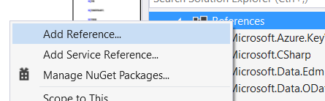

Select “System.Configuration”
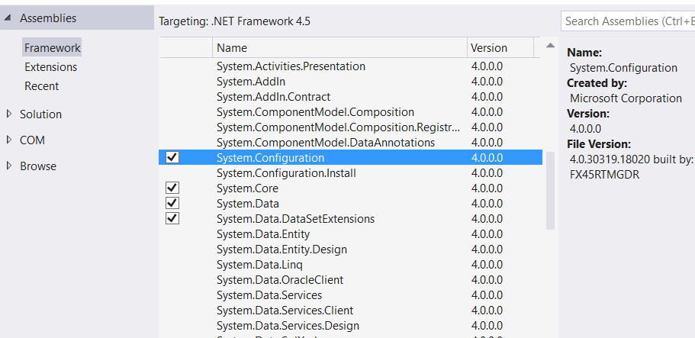

Step 6: Open Program.cs file
Add references of Azure Storage
using System.Configuration;
using Microsoft.WindowsAzure.Storage;
using Microsoft.WindowsAzure.Storage.Auth;
using Microsoft.WindowsAzure.Storage.Queue;

static void Main(string[] args)
{
//Retrieve Storage account from connection string
CloudStorageAccount storageAccount = CloudStorageAccount.Parse(ConfigurationManager.AppSettings["StorageConnectionString"]);

//Get a reference to the Queue client
CloudQueueClient queueClient = storageAccount.CreateCloudQueueClient();

//Get a reference to a Queue object
CloudQueue queue = queueClient.GetQueueReference("storagequeue");
queue.CreateIfNotExists();

}

Output : storagequeue will generate

Adding messages to a queue
You can access your storage queues and add messages to a queue using many storage browsing tools; however, it is more likely you will add messages programmatically as part of your application workflow.
static void Main(string[] args)
{
//Retrieve Storage account from connection string
CloudStorageAccount storageAccount = CloudStorageAccount.Parse(ConfigurationManager.AppSettings["StorageConnectionString"]);

//Get a reference to the Queue client
CloudQueueClient queueClient = storageAccount.CreateCloudQueueClient();

//Get a reference to a Queue object
CloudQueue queue = queueClient.GetQueueReference("storagequeue");
queue.CreateIfNotExists();

queue.AddMessage(new CloudQueueMessage("Message #1"));
queue.AddMessage(new CloudQueueMessage("Message #2"));
queue.AddMessage(new CloudQueueMessage("Message #3"));

}

Run the project
Server Explorer -> Azure Subscription -> Storage -> StorageName -> Queues
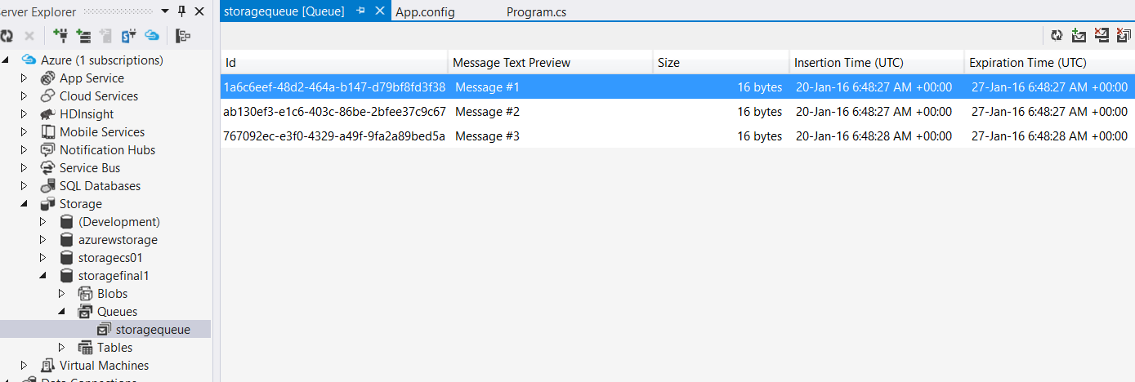

Peek messages
Add one more reference
using System.Diagnostics;

static void Main(string[] args)
{
//Retrieve Storage account from connection string
CloudStorageAccount storageAccount = CloudStorageAccount.Parse(ConfigurationManager.AppSettings["StorageConnectionString"]);

//Get a reference to the Queue client
CloudQueueClient queueClient = storageAccount.CreateCloudQueueClient();

//Get a reference to a Queue object
CloudQueue queue = queueClient.GetQueueReference("storagequeue");
queue.CreateIfNotExists();

//queue.AddMessage(new CloudQueueMessage("Message #1"));
//queue.AddMessage(new CloudQueueMessage("Message #2"));
//queue.AddMessage(new CloudQueueMessage("Message #3"));

CloudQueueMessage peekedMessage = queue.PeekMessage();
Debug.WriteLine(peekedMessage.AsString);

}

Run the Project
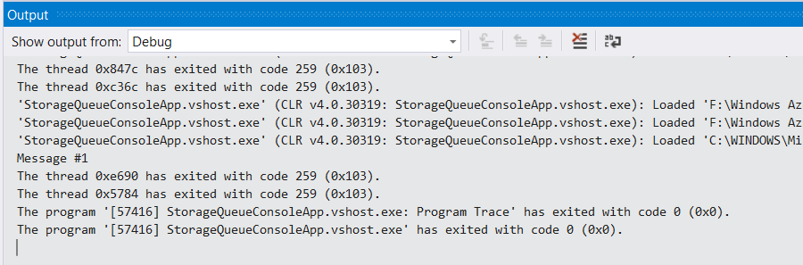

Peek messages – multiple messages

CloudQueueMessage message1 = queue.GetMessage();
CloudQueueMessage message2 = queue.GetMessage();
Debug.WriteLine(message1.AsString);
Debug.WriteLine(message2.AsString);

again run the project
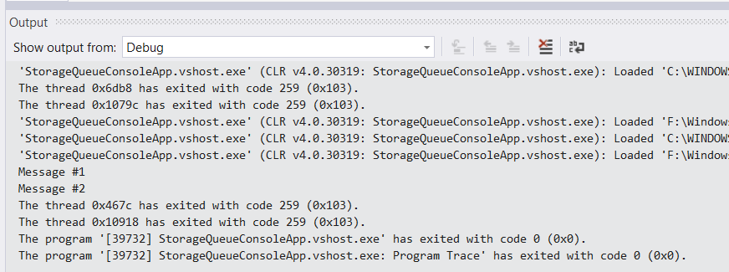

Open Queues from Azure Storage Explorer. So only Message #3 available
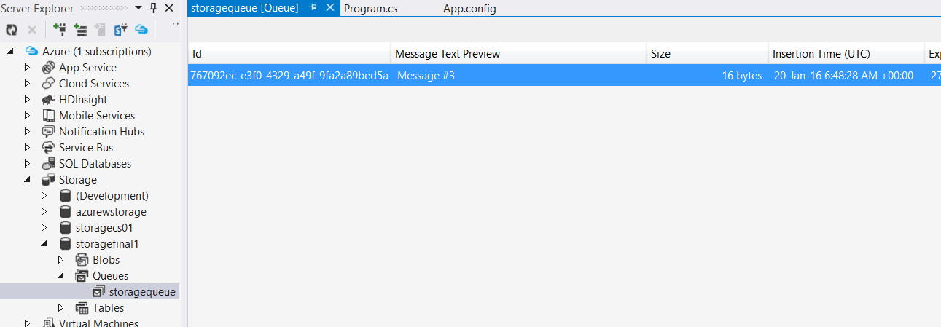

Click on refresh button.
Message #1, Message #2 available in the queue
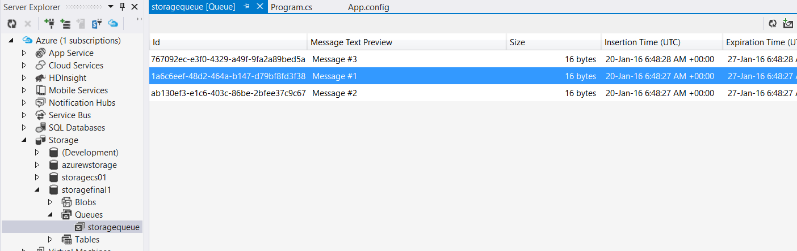

Deleting Message
queue.DeleteMessage(message1);
Again click on refresh button – Message #2
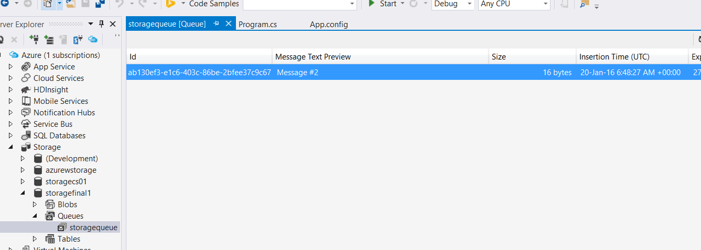
Again click on refresh button – Message #2, Message #1
